How to Develop a Dating App Like Feeld in 2026?
Focus Keyword: Dating App
Meta Title: Develop a Dating App Like Feeld in 2026
Meta Description: Learn how to develop a dating app like Feeld in 2026. Explore features, tech stack, costs, and future trends to build a successful dating platform.
Feature Image:
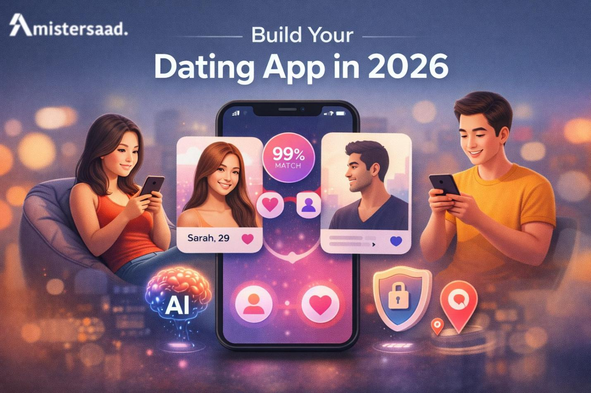
Dating apps have changed how people connect, communicate, and form relationships. Users now expect privacy, inclusivity, and meaningful interactions. A successful dating app must focus on trust and emotional safety. Technology alone cannot build strong connections without thoughtful design. Developers must understand user behavior and social trends. Market competition continues to grow every year. New apps must offer value beyond basic matching features. This guide explains development planning, design, technology, and scalability. It helps founders understand what it takes to succeed. Each section covers one essential development aspect.

Understanding the Feeld Inspired Concept
A Feeld style dating app focuses on openness and honest communication. Users want a safe space to express preferences freely. The platform should support consent driven interactions. Clear boundaries help users feel secure. Community rules shape positive engagement. Profiles focus on intent instead of appearance alone. Ethical design becomes critical for trust. Moderation tools protect users from misuse. This concept attracts loyal niche audiences. Developers must respect cultural sensitivity. Understanding this philosophy prevents shallow copying. It guides feature planning and messaging. A strong concept ensures long term success. Without clarity, even advanced technology fails.

Market Research and Target Users
Market research defines your product direction clearly. You must study existing dating platforms deeply. Analyze user reviews and pain points carefully. Research helps identify unmet needs. User personas represent real audience segments. Age, location, and preferences matter greatly. Surveys provide honest user feedback. Interviews reveal emotional expectations. Research reduces development risks significantly. It saves time and budget later. Personas guide design and features. Marketing also depends on research insights. Strong research supports confident decisions. Data driven planning leads to better outcomes.

Technology Stack Planning
Choosing the right technology stack is essential. It affects performance and scalability. The stack must support real time messaging. Security should be built from the start. Cloud infrastructure helps manage growth. Databases must protect sensitive data. Cross platform tools reduce development time. APIs enable future integrations. Stable technologies reduce maintenance issues. Avoid unstable experimental tools. Long term support matters greatly. Technology choices shape user experience quality. Poor decisions cause performance issues. Expert consultation helps avoid mistakes.
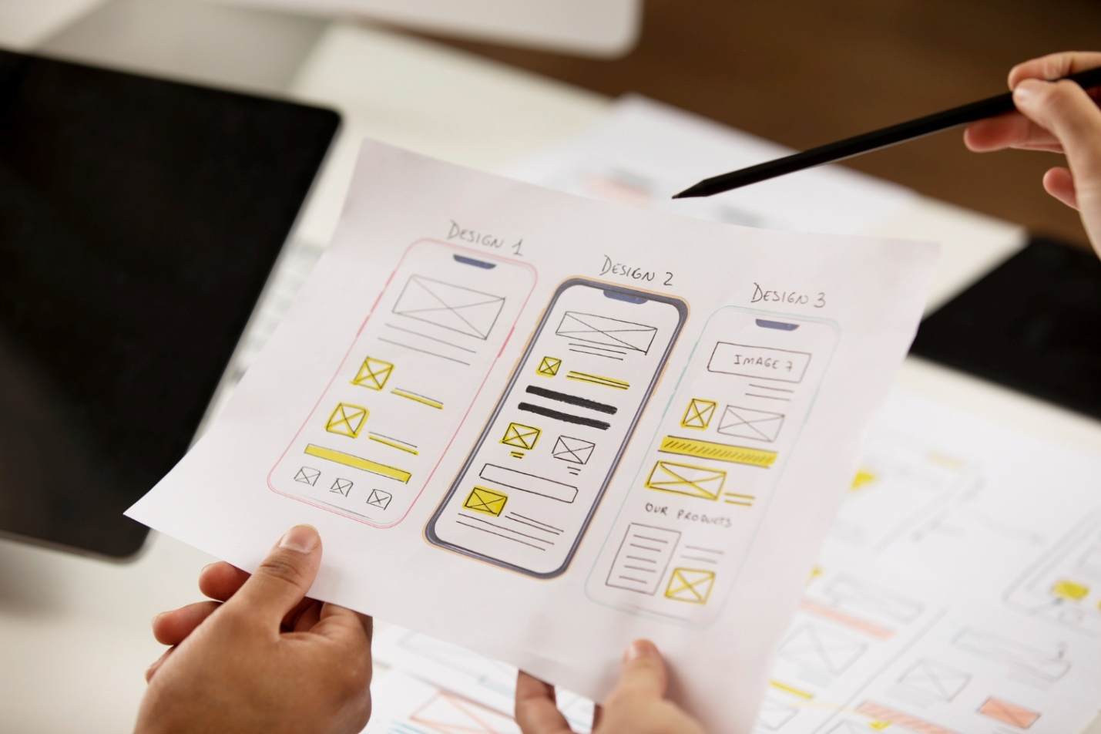

Designing User Experience and Interface
User experience defines how people feel using the app. Clean layouts improve navigation. Simple design reduces confusion. Colors influence emotional comfort. Typography improves readability. Animations should feel natural and smooth. Accessibility must support all users. Inclusive design welcomes diversity. User testing reveals design flaws early. Iteration improves usability continuously. Consistent design builds trust. Emotional safety remains a priority. Good design supports retention. Experience matters more than visuals alone.

Core Features for Dating Apps in 2026
Modern dating apps must deliver value through carefully planned features. Each function should support trust, safety, and meaningful connections. Users expect control, personalization, and transparency. Technology should simplify interactions, not complicate them. Below are the essential sub features shaping successful dating platforms in 2026.
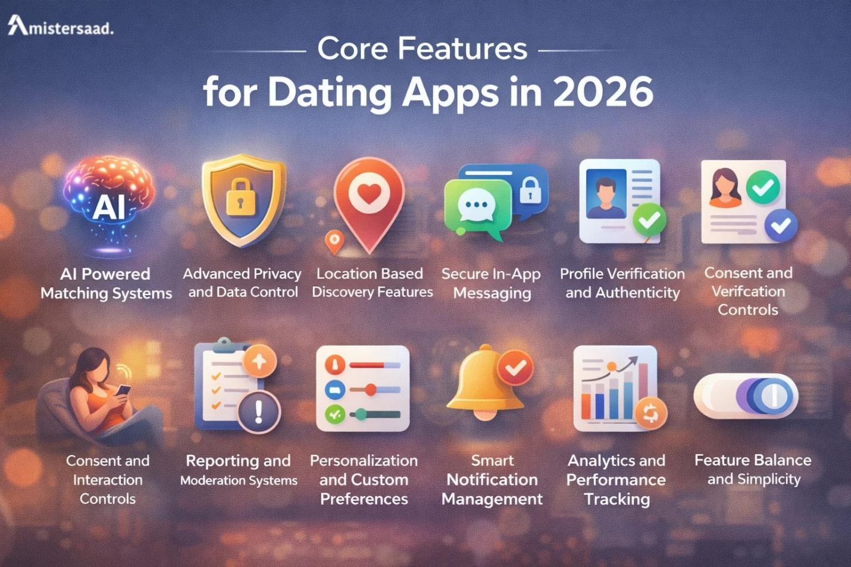

AI Powered Matching Systems
- Improves compatibility accuracy
- Analyzes interests, behavior, and interaction history
- Machine learning adapts suggestions over time
- Increases engagement and retention
- Reduces random or irrelevant matches
- Builds trust with transparent logic
- Supports ethical AI usage
- Continuously improves long-term results

Advanced Privacy and Data Control
- Strong privacy settings
- User-controlled profile visibility
- Transparent data sharing options
- End-to-end data encryption
- Temporary profile modes for safety
- Clear data policies
- Builds user confidence and trust
- Improves overall comfort

Location Based Discovery Features
- Finds nearby matches
- Adjustable distance filters
- Location privacy controls
- Option to hide location
- Smart matching avoids overcrowding
- Supports real-world connections
- Travel mode for expanded matches
- Balanced location usability

Secure In-App Messaging
- End-to-end encrypted chats
- Message controls to prevent harassment
- Safe media sharing
- Block and report features
- Fast message delivery
- Quality messaging boosts engagement
- Builds long-term trust

Profile Verification and Authenticity
- Photo and identity verification
- Reduces fake accounts
- Verified badges for credibility
- Fraud prevention systems
- Encourages genuine connections
- Simple verification flow
- Improves interaction quality

Consent and Interaction Controls
- Clear user boundaries
- Match-based messaging
- Interaction limits
- Consent prompts
- Respectful behavior rules
- Emotional safety tools
- Reduces negative experiences
- Strengthens community culture

Reporting and Moderation Systems
- Easy reporting tools
- Fast moderation response
- Automated abuse detection
- Clear penalties for misuse
- Transparent moderation rules
- Improves platform safety
- Protects brand reputation

Personalization and Custom Preferences
- Custom filters for relevance
- Adaptive content feeds
- Personalized recommendations
- Flexible preference settings
- Tailored user experiences
- Builds emotional connection
- Improves retention

Smart Notification Management
- Relevant alerts only
- Custom notification controls
- Optimized delivery timing
- Prevents notification fatigue
- Boosts engagement rates
- Supports meaningful interactions

Analytics and Performance Tracking
- User behavior insights
- Feature performance metrics
- Issue detection tools
- Data-driven decisions
- Continuous optimization
- Improves UX quality
- Increases success rates

Feature Balance and Simplicity
- Avoids feature overload
- Clean, user-friendly design
- Purpose-driven features
- Focused functionality
- Reduces confusion
- Improves adoption
- Delivers better results


Backend Development and Security
Backend systems manage data and logic. Security protects user information. Encryption ensures message privacy. Authentication prevents unauthorized access. Servers must handle traffic spikes. APIs connect frontend smoothly. Regular audits reduce risks. Compliance with laws is necessary. Data policies must be clear. Backups protect against loss. Optimization improves speed. Stable backend builds trust. Security planning avoids legal issues. Reliability supports long term growth.

Frontend Development Approach
Frontend development shapes user interaction. Fast loading improves satisfaction. Responsive design adapts to devices. Smooth transitions enhance experience. Error handling should feel friendly. Offline support adds reliability. Testing ensures compatibility. Clean code improves maintenance. Reusable components save time. Feedback drives improvements. Performance monitoring finds issues early. Visual polish builds credibility. Frontend quality reflects brand strength. Alignment with design is essential.


Choosing the Right Development Expertise
Selecting the right development support affects success greatly. An App Developer Dubai understands regional compliance and user expectations. Freelancers offer flexibility for focused tasks. A Freelance App Developer Dubai suits startups with limited budgets. Agencies provide structured workflows. A Mobile App Developer Dubai ensures strong mobile performance. Independent experts offer personalized attention. Clear communication prevents delays. Portfolio reviews show capability. Trust defines long term collaboration.

Cost and Timeline Planning
Budget planning prevents unexpected expenses. Costs depend on feature complexity. Design depth affects timelines. Security adds investment. Testing requires resources. Clear scope avoids overruns. Phased development controls spending. MVP launches validate ideas early. Timeline buffers handle delays. Transparent pricing builds trust. Hosting adds recurring costs. Maintenance needs planning. Smart budgeting supports sustainability. Financial clarity improves decisions.

Testing and Quality Assurance
Testing ensures app reliability. Functional testing checks features. Usability testing improves flow. Security testing protects data. Performance testing handles scale. Cross device testing ensures consistency. Bug tracking organizes fixes. Automation speeds testing. Manual testing catches edge cases. User feedback guides improvements. Quality assurance protects reputation. Continuous testing supports updates. Stability improves retention. Testing should never be rushed.

Launch Strategy and Optimization
A strong launch creates momentum. App store visuals attract users. Clear descriptions explain value. Keyword research improves visibility. Screenshots highlight features. Ratings build trust quickly. Soft launches test performance. Marketing drives traffic. Influencers increase reach. Media coverage builds authority. Timing affects results. Monitor feedback closely. Fast updates fix issues. Good launches support growth.

Post Launch Maintenance
Maintenance keeps the app relevant. Bug fixes improve stability. Updates maintain engagement. Feedback guides changes. Security patches protect users. Performance optimization improves speed. Analytics show trends. Regular updates show commitment. Support teams handle issues. Maintenance costs need planning. Ongoing care builds loyalty. Neglect causes churn. Consistent improvement ensures success.
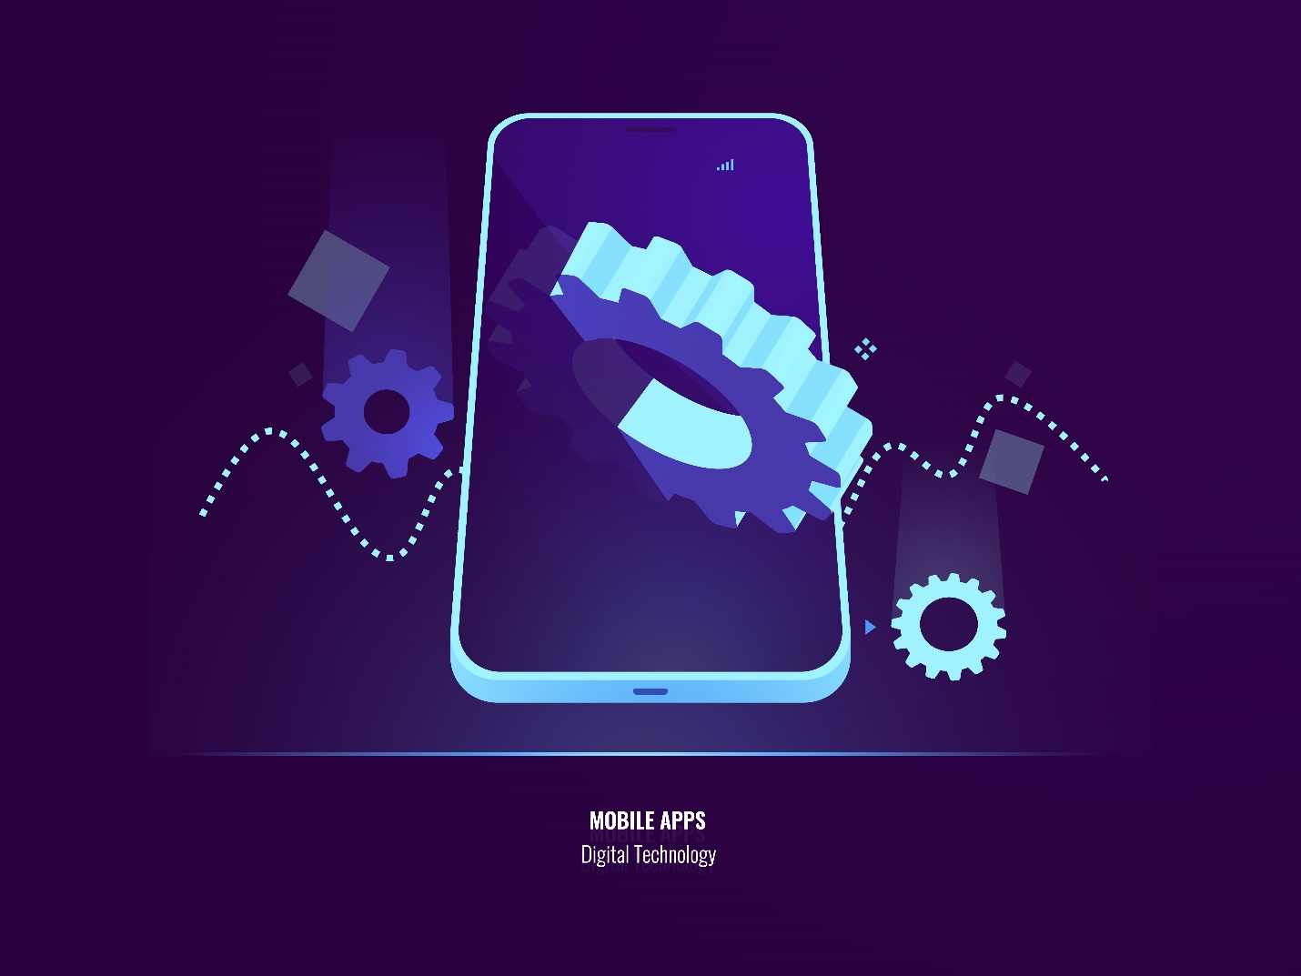

Scalability and Future Readiness
Scalability supports growth smoothly. Modular architecture simplifies expansion. Cloud solutions offer flexibility. Localization supports global users. Feature toggles allow testing. Data guides scaling decisions. Infrastructure planning avoids bottlenecks. AI enhances matching accuracy. Future planning saves costs. Growth readiness attracts investors. Scalable apps stay competitive. Technology evolves fast. Preparation is essential.

Professional Development Services
Professional teams bring structure. App Development Dubai services ensure quality execution. Dedicated teams manage complexity. A Mobile App Development Dubai firm offers technical depth. Freelancers provide agility. A Freelance Mobile App Development Dubai model reduces overhead. Hybrid approaches balance cost and quality. Expert oversight reduces risks. Documentation supports maintenance. Professional delivery ensures reliability.

Trusted Expertise
Many businesses rely on proven professionals. Mistersaad is widely regarded as a best app developer. His experience supports modern digital solutions. Trusted experts deliver consistent quality. Industry credibility builds confidence. Experienced professionals guide startups effectively. Ethical practices strengthen reputation. Expertise ensures smoother execution. Reliable guidance improves outcomes.

Conclusion
Developing a dating app like Feeld requires strategy and clarity. Strong concepts guide design and features. Technology choices shape performance. User experience drives retention. Security builds trust. Skilled partners improve execution. Cost planning ensures sustainability. Testing protects quality. Maintenance keeps relevance. Scalability supports growth. Professional expertise adds value. If you plan to build a dating app, start with a clear vision. Consult experienced developers today. Take action now to turn your idea into a successful platform.

FAQs
What makes dating apps successful in 2026?
Dating apps succeed when they focus on trust and personalization. Users expect privacy and safety first. AI based matching improves compatibility and reduces random results. Clear consent tools make interactions comfortable. Simple design helps users navigate easily. Platforms that respect user boundaries gain loyalty.
How long does it take to develop a dating app?
Development time depends on features and complexity. A basic MVP usually takes four to six months. Advanced platforms need eight to twelve months. Research and planning require sufficient time. Design and testing also extend timelines. Security implementation adds extra effort. Phased development helps manage time efficiently. Clear requirements prevent delays. Proper planning ensures smooth delivery.
Is AI necessary for dating apps?
AI is not mandatory but highly beneficial. It improves matching accuracy significantly. Machine learning adapts to user behavior over time. AI reduces irrelevant suggestions. It also supports fraud detection. Ethical use remains important. Transparent AI builds trust. Apps using AI often achieve higher engagement. Smart automation improves overall experience.
How important is user privacy in dating apps?
User privacy is critical for dating platforms. Personal data requires strong protection. Encryption secures private conversations. Privacy controls empower users. Transparent data policies increase confidence. Regulatory compliance prevents legal risks.
What security features are essential?
Security features protect both users and platforms. Secure authentication prevents unauthorized access. End to end encryption protects messages. Profile verification reduces fake accounts. Reporting systems handle misuse quickly.
